Agenda
10:00 Arrive and Sign- In
10:30 Welcome and Tour- Dawn Neal (Southeastern Livestock Pavilion)
11:00 Regular Business – Emily Nolen (FDACS)
- Current In-Kind Partner Contributions
- Incident Command System (ICS) Training Opportunities
- Reminder: Review SART Partner Contact List for Updates
- Reminder: FDOT Weight Waiver for Agricultural Commodities – Extended date Dec. 23, 2023
- SART Website Update
- Upcoming SART Funded Trainings
11:10 Forensic Veterinary Technology – Allison Kennedy-Benson (FVTA)
11:30 Florida Agricultural Interdiction Stations Update –Office of Agricultural Law Enforcement (FDACS)
11:50 2024 SART Full Scale Exercise Update and Discussion – Emily Nolen (FDACS)
12:20 SART Partner Updates– All
12:30 – 1:00 Potluck meal celebrating the Holiday Season!

Next SART Virtual Meeting: Monday, January 17th, 2024
Microsoft Teams
10:00 am – 11:00 am
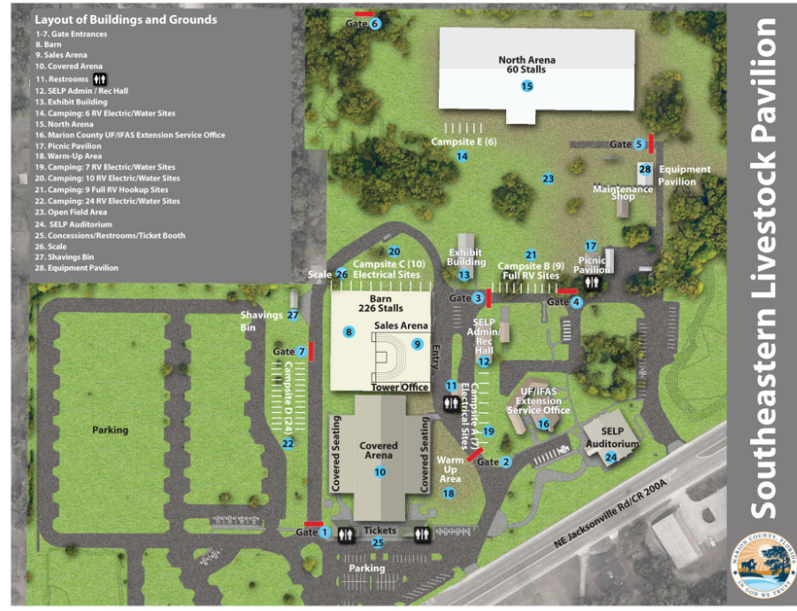
= Parking Available.
= Meeting Site.
Meeting taking place at #24 – SELP Auditorium. Parking available at the star marked location.

